AFFECTIVE DISORDER
The essential feature of major depressive disorder is a clinical course characterized by one or more major depressive episodes without a history of manic or hypomanic episodes.
Major Depressive Disorder (MDD, or referred to here as “depression”) where people with depression suffer greatly with persistent feelings of hopelessness, dejection, constant worry, poor concentration, a lack of energy, an inability to sleep and, sometimes, suicidal tendencies.
ETIOLOGY
- Hormonal imbalance
- Life stress
- Personality type
- Chemically induced (drug induced)
RISK FACTORS
- Age less than 40 years
- Sex- females more prone
- Impaired Interpersonal relationship
- Divorced or widowers
- Family history of depression
- Negative life event
CLINICAL PRESENTATION
Emotional Symptoms
- Diminished ability to experience pleasure
- Loss of interest and pleasure in usual activities, hobbies, or work (anhedonia)
- Pessimism, hopelessness regarding feeling better
- Anxiety
- Voices (auditory hallucinations) saying negative comments or suggesting suicide
Physical Symptoms
- Chronic fatigue resulting in decreased ability to attend to daily tasks (eg, bathing, grooming)
- Fatigue does not improve with rest and is often associated with pain, headache
- Changes in sleep (early morning awakening, difficulty falling asleep, frequent awakening or increased sleep with associated fatigue)
- Appetite changes (most common decreased appetite and unintentional weight loss; some patients may eat more)
- Gastrointestinal disturbances, genitourinary issues, cardiovascular complaints (eg, palpitations), loss of libido
Cognitive Symptoms
- Decreased concentration or slowed thinking
- Poor memory for recent events (especially elderly)
- Confused or indecisive

Psychomotor Disturbances
- Slow physical movements, speech and thought processes (psychomotor retardation)
- Restlessness (eg, pacing, wringing of hands), outbursts of anxiety or agitation (eg, crying or yelling); together known as psychomotor agitation
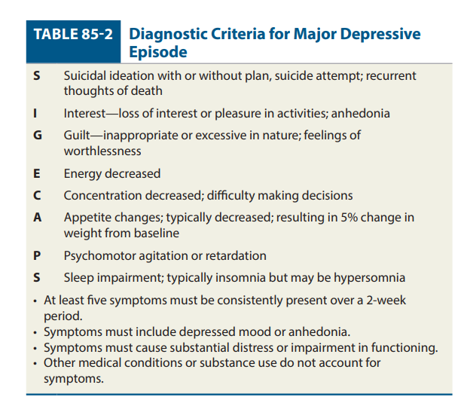
Diagnostic and Statistical Manual of Mental Disorders, Fifth Edition (DSM-5)
DRUGS CAUSING DEPRESSION
- Isotretinoin
- Angiotensin receptor blockers
- β-blockers
- Calcium channel blockers
- Clonidine
- Methyldopa
- Deutetrabenazine
- Tetrabenazine
- Valbenazine
- Gonadotropin-releasing hormone
- Oral contraceptives

DYSTHEMIA- a chronic depressive state that does not meet criteria for the depressive episode anytime and last upto 2 years.

TREATMENT
GOAL OF THERAPY
- to reduce symptoms of depression
- minimize adverse effects,
- ensure adherence to the prescribed regimen,
- facilitate return to premorbid functioning, and
- prevent further depressive episodes.
- Psychoeducation
NON-PHARMACOLOGICAL THERAPY
- Psychotherapy may be first-line therapy for mild to moderately severe major depressive episode. The efficacy of psychotherapy and antidepressants is considered to be additive.
- Electroconvulsive therapy (ECT) is a safe and effective treatment for major depressive disorder. It is considered when a rapid response is needed, risks of other treatments outweigh potential benefits, there is history of a poor response to drugs, and the patient prefers ECT. A rapid therapeutic response (10–14 days) has been reported.
- Repetitive transcranial magnetic stimulation has demonstrated efficacy and does not require anesthesia as does ECT.
- Psychoeducation and cognitive behavioural therapy (CBT)
PHARMACOTHERAPY
Selective Serotonin Reuptake Inhibitors (SSRIs)
DRUGS | DOSE | USAUAL RANGE (mg/day)
Citalopram | 20 | 20-40 | Doses >40 mg/day not recommended due to QT prolongation risk; maximum 20 mg/day for CYP2C19 poor metabolizers or coadministration with CYP2C19 inhibitors; 20 mg/day recommended for patients older than 60 years of age
Escitalopram | 10 | 10-20 | Maximum 20 mg/day; dose may be increased to maximum daily dose after at least 1 week if needed; 5-mg tablet available for unique circumstances
Fluoxetine | 20 | 20-60 | Maximum 80 mg/day; dose may be increased in 20-mg increments; doses of 5 or 10 mg/day have been used as initial therapy; doses >20 mg/day may be given in a single daily dose or divided twice daily
Sertraline | 50 | 50-200 | Maximum 200 mg/day; titrate 25 mg/day increments weekly

Serotonin–Norepinephrine Reuptake Inhibitors (SNRIs)
DRUG | DOSE | USUSAL RANGE (mg/day)
Venlafaxine | 37.5-75 | 75-225 | Maximum 375 mg/day (IR); maximum 225 mg/day (ER); may increase in increments up to 75 mg/day at a minimum of every 4 days. Dose reductions or discontinuation may be required if sustained hypertension occurs
Duloxetine | 30 | 30-90 | Maximum 120 mg/day (given once or twice daily); doses exceeding 60 mg/day not shown to provide increased efficacy for the treatment of MDD

Tricyclic antidepressant
DRUG | DOSE | USUAL RANGE (mg/day)
Amitriptyline | 25 | 100-200 | Maximum 300 mg/day for MDD; depending on the total dose, it may be given as a single daily dose at bedtime or in divided doses throughout the day; therapeutic serum level 100-250 ng/mL (mcg/L; 370-925 nmol/L); parent drug plus metabolite (nortriptyline)
Imipramine | 25 | 100-200 | Maximum 300 mg/day; may be given in a single daily dose at bedtime (if tolerated) or in divided doses throughout the day; suggested therapeutic concentration range for combined imipramine + desipramine: 150-300 ng/mL (mcg/L; 550-1,100 nmol/L)
Desipramine | 25 | 100-200 | Maximum 300 mg/day; suggested therapeutic concentration range for combined imipramine + desipramine: 150-300 ng/mL (mcg/L; 550-1,100 nmol/L)

Monoamine oxidase inhibitors
DRUG | DOSE | USUSUAL RANGE (mg/day)
Phenelzine | 15 | 30-90 | Divided dosing 2 to 3 times daily; dosing may be increased to 90 mg/day based on tolerance and response
Selegiline | 6 | 6-12 | Not to exceed 12 mg/24 hours; dose may be increased by 3 mg/day increments every 2 weeks; site of application should be rotated

SIDE EFFECTS -Sexual side effects: i libido, ejaculation difficulties, anorgasmia, erectile dysfunction .Somnolence, insomnia, nausea, dry mouth, diaphoresis (dose-related), weakness, tremor, dizziness, headache (but may help for migraines if taken continuously)
SIDE EFFECTS OF TCA
Cardiotoxicity QT prolongation with overdose (monitor for suicidal ideation, as overdose can quickly cause fatal arrhythmias);obtain baseline ECG if cardiac risk factors or age> 50 years old Orthostasis, tachycardia.
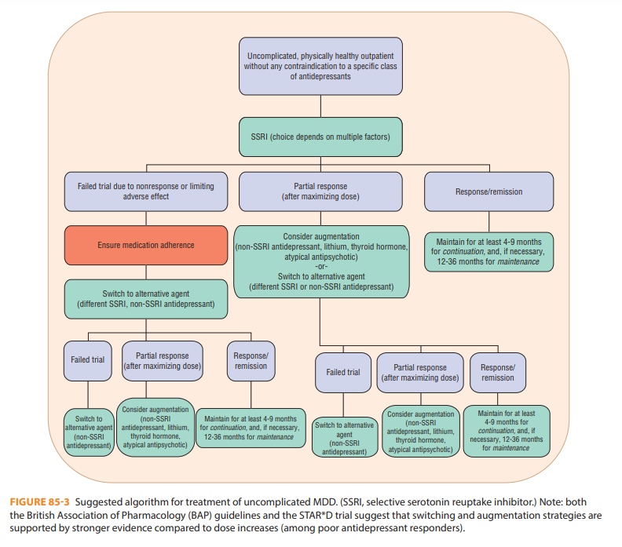

BIPOLAR DISORDER-
- Bipolar disorder is a common, chronic, and often severe cyclic mood disorder characterized by recurrent fluctuations in mood, energy, and behavior.
- It differs from recurrent major depression (or unipolar depression) in that a manic or hypomanic episode occurs during the course of the illness.
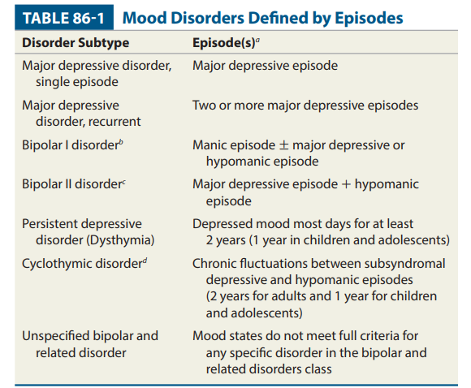
ETIOLOGY
- Genetic factor
- Neurobiological factor
- Psychological factor
RISK FACTORS
- Family history- 1st degree relative
- Twins
- Genetic linkage studies suggest multiple gene loci may be involved in the heredity of mood disorder.
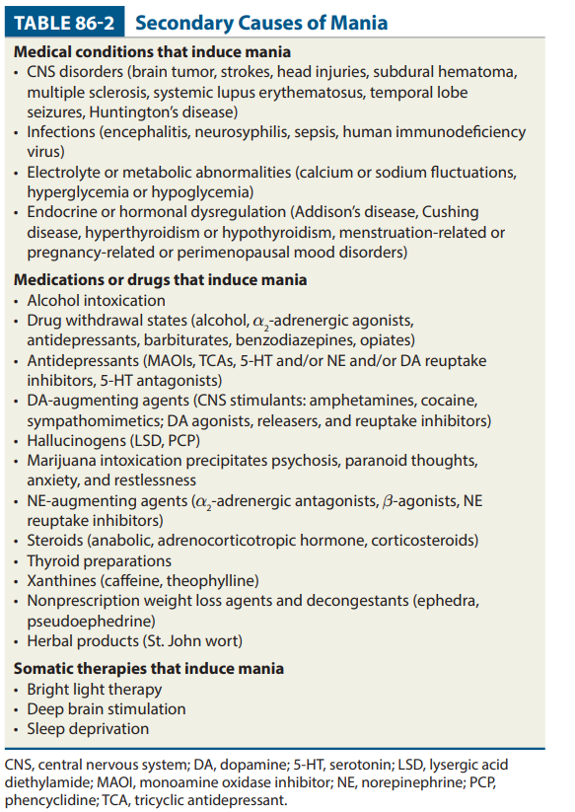

CLINICAL PRESENTATION
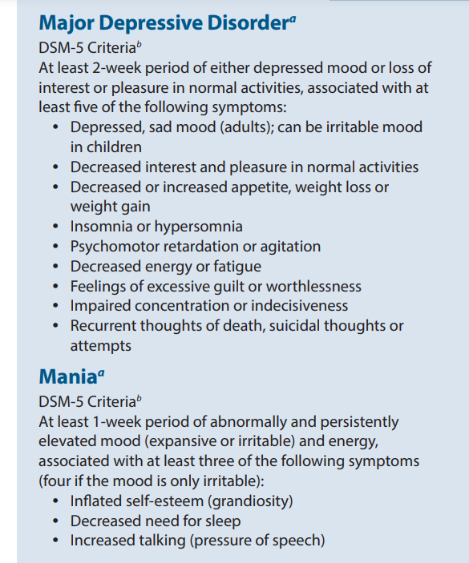
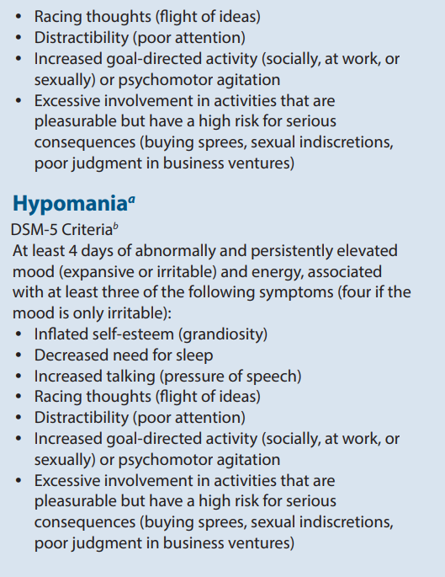
TREATMENT
GOAL OF THERAPY
- Eliminate mood episode with complete remission of symptoms (ie, acute treatment)
- Prevent recurrences or relapses of mood episodes (ie, continuation phase treatment)
- Return to baseline psychosocial functioning
- Maximize adherence with therapy
- Minimize adverse effects
- Use medications with the best tolerability and fewest drug interactions
- Minimize polypharmacy when possible
- Treat comorbid substance use and abuse
- Eliminate alcohol, marijuana, cocaine, amphetamines, and hallucinogens
- Minimize nicotine use and stop caffeine intake at least 8 hours prior to bedtime
- Avoidance of stressors or substances that precipitate an acute episode
NON-PHARMACOLOGICAL THERAPY
- psychotherapy (eg, individual, group, and family), interpersonal therapy, and/or cognitive behavioral therapy,
- stress reduction techniques, relaxation therapy, massage, and yoga,
- sleep (regular bedtime and awake schedule; avoid alcohol or caffeine intake prior to bedtime),
- nutrition (regular intake of protein-rich foods or drinks and essential fatty acids; supplemental vitamins and minerals), and
- exercise (regular aerobic and weight training at least three times a week).

PHARMACOTHERAPY
MOOD STABILISING DRUG- Lithium, carbamazepine, sodium valproate
Algorithm and Guidelines for the Acute Treatment of Mood Episodes in Patients with Bipolar I Disorder
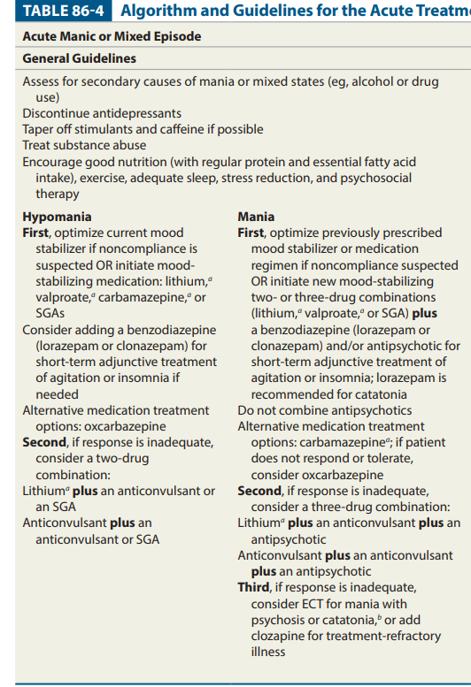
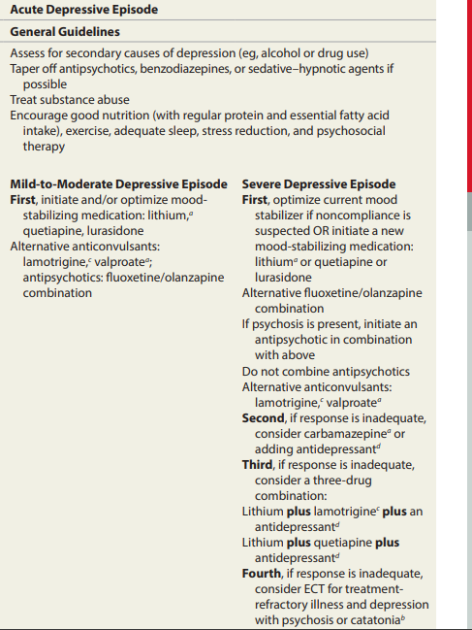
LITHIUM SALTS
DRUG | DOSE | USUAL RANGE
Lithium | 300 mg BD | 900-2,400 mg/day in two to four divided doses, preferably with meals

ANTICONVULSANTS
DRUG | DOSE | USUAL RANGE
Valproate sodium | 250-500 mg BD | 750-3,000 mg/day (20-60 mg/kg/day) given once daily or in divided doses Titrate to clinical response Dose adjustment needed with hepatic impairment
Carbamazepine | 200 mg BD | 200-1,800 mg/day in two to four divided doses Titrate to clinical response Dose adjustment needed with hepatic impairment
Lamotrigine | 25 mg | 50-400 mg/day in divided doses. Dosage should be slowly increased (eg, 25 mg/day for 2 weeks, then 50 mg/day for weeks 3 and 4, and then 50-mg/day increments at weekly intervals up to 200 mg/day)

ATYPICAL ANTIPSYCHOTICS
DRUG | DOSE | USUAL RANGE
Olanzapine | 2.5-5 mg twice daily | 5-20 mg/day once daily or in divided dose
Quetiapine | 50 mg twice daily | 50-800 mg/day in divided doses or once daily when stabilized
Risperidone | 0.5-1 mg twice daily | 0.5-6 mg/day once daily or in divided doses

ADRs-
- Diarrhoea
- polydipsia with polyuria
- Hand tremor
- Other adverse effects associated with the use of lithium include: acne and folliculitis (1%), reversible leukocytosis, and weight gain.
- T-wave flattening or inversion
- atrioventricular block, and
- bradycardia.
QUESTION
- Symptoms of depression (2)(2)
- Define depression (2)
- Manik Write a short note on manic disorder (2)
- Write about the typed and symptoms of disorder (15 mark in combination)
- Write diagnostic criteria and treatment algorithm of depression (15 mark in combination)
- Write about mood stabilizers used in bipolar mood disorders (2)

